Minor PROJECT REPORT

ON

“Library Management System”

**In partial fulfillment for the award of the degree**

**Of**

**BACHELOR OF COMPUTER APPLICATION**

**[B.C.A]**

**Year 2023-2024**

SUBMITED BY GUIDED BY

NIRAJ S. PARADVA Prof. Pratiksha Patel

**BCA-5th SEMESTER**

**Submitted to:**



**SHRI SHAMBHUBHAI V. PATEL COLLEGE OF**

**COMPUTER SCIENCE & BUSINESS MANAGEMENT**

Affiliated to

**Veer Narmad South Gujarat University**

**List of Abbreviations**

* GUI: Graphical user interface.
* DMS: Database management system.
* LMS: library management system.
* HTML: Hypertext Markup Language.
* CSS: Cascading style sheets.
* RDMS: Relational database management system.
* PHP: Hypertext Preprocessor
* AJAX: Asynchronous JavaScript and XML
* UML: Unified Modeling Language

Acknowledgement

The satisfaction that accompanies that the successful completion of any task would be incomplete without the mention of people whose ceaseless cooperation made it possible, whose constant guidance and encouragement crown all efforts with success.

We are grateful to our project guide **Prof. Pratiksha Patel** for the guidance, inspiration and constructive suggestions that helpful us in the preparation of this project. We also thank **my friends** who have helped in successful completion of the project.

I also like to thanks our **all the professor** who are always ready to give best guide. They are the person who gives solution whenever needed.

Contents

introduction **Error! Bookmark not defined.**

Tools used for the project 5

Php 5

Sql 6

MySql 6

Bootstrap 6

JavaScript 6

Objective 7

Unified Modelling Language 7

ER Diagram 7

data flow diagram 9

flow chart 10

Screen short of site 10

home page 10

Register and login forms (admin, student) 13

student dashboard 14

admin dashboard 18

Conclusion 25

# Introduction

A library is a collection of well-organized information and resources that is made available for borrowing to a certain group of people. With the advent of technology, it is very important to make all systems more user-friendly. Library Management System (LMS) is a software program that allows physical libraries to be converted into digital libraries. A Library Management System (LMS) allows the user to keep track of both the books and the customers. The system's deployment in the company will significantly decrease data entry, time, and deliver easily computed results. It assists in keeping track of all information on the books in the library, including their pricing, status, and total quantity. Instead of utilizing the manual writing system, the user will find it easier to use this automated system

The main purpose of the project is to is to build an online LMS system by using different software methodologies. The LMS with the basic and necessary features like the admin/librarian can add/delete book, can add/delete author, can issue books, can manage books and users, and users/students can search and borrow books. For Frontend part of the project used HTML, CSS, JavaScript and Bootstrap framework and for the Backend part used PHP and MySQL database. For Unified modeling language (UML) design in online site ucidchart.

# Tools used for the project

I used HTML, CSS, JavaScript and Bootstrap framework for Frontend part. Frontend development is a type of computer programming that focuses on the coding and building of a website, which will be visible to the user. It's about ensuring that a website's visual elements are functioning. And for the Backend part uses PHP and MySQL. The server side of a program and anything that connects between the database and the browser is referred to as back-end development.

## Php

PHP is a scripting language developed by Rasmus Lerdorf in 1994. Originally, he wrote several C programs to execute various tasks on his static website, which he had constructed for himself on the internet. He had unknowingly established the groundwork for a new programming language. The primary goal was to connect with the servers and databases where his static files were stored.

PHP is a server-side programming language that is free, open sourced and object oriented. PHP is a good option for developing websites.

## Sql

SQL stands for Structured Query Language, and it is a programming language that may be used to store, alter, and retrieve data from a database system. A relational database.

A relational database management system (RDBMS) allows users to obtain access to data.

### MySql

MySQL is a SQL-based relational database management system. MySQL enables users to manage, save, change, and remove data, as well as organize data. MySQL has an integrated tool called MySQL Workbench that simplifies the process of developing, designing, and constructing databases. MySQL comes in a variety of forms and is updated often. MySQL, being an open-source platform, provides a large and active community of users and developers.

## Bootstrap

Bootstrap is a framework that works with HTML, CSS, and JavaScript to create dynamic and device-friendly webpages. It's a simple and quick web development framework to use. It's a framework for front-end development. For websites and applications, developers may create multifunctional, user-friendly, and beautiful front-end designs.

Bootstrap comes with ready-to-use components that make it easier for developers to design websites on a tight schedule. Developers don't have to start from the beginning, and they may tweak particular components depending on one’s suggestions to make it unique. Whether an expert or a novice in web design, a user may effortlessly install Bootstrap. Users do not need to be experts in internet technology (HTML, CSS, or JavaScript) to get started; they may start with the basics.

## JavaScript

JavaScript is a scripting language for beginners with a wide variety of features. As one gets more experience with JavaScript, one will be able to create games, animated 2D and 3D images, database-driven systems, and more.

# Objective

The purpose of a library management system is to manage & track the daily work of the library such as issuing books, return books, due calculations, etc.

Helps With Multitasking

Makes Library Cost-Effective

Eliminates/Reduces Errors in Data Management

Easy Accessibility

# Unified Modeling Language

it is abbreviated as UML, which stands for Unified Modeling Language. It is a standardized modeling language consisting of an integrated set of diagrams that was developed to assist system and software developers in specifying, visualizing, constructing, and documenting the artifacts of software systems, as well as for business modeling and other non-software systems. With the Unified Modeling Language (UML), users may model big and complex systems using best engineering techniques that have been shown to work in previous modeling projects.

The Unified Modeling Language (UML) is a critical component in developing object-oriented applications and the software development life cycle. The Unified Modeling Language (UML) is a graphical notation system that is used to represent the design of software projects. When project teams use the UML, they may communicate more effectively, explore possible designs, and verify the architectural design of the program.

## ER Diagram

An entity-relationship diagram, or ER diagram, is essential for modeling the data stored in a database. It is the basic design upon which a database is built. ER diagrams specify what data we will store: the entities and their attributes. They also show how entities relate to other entities

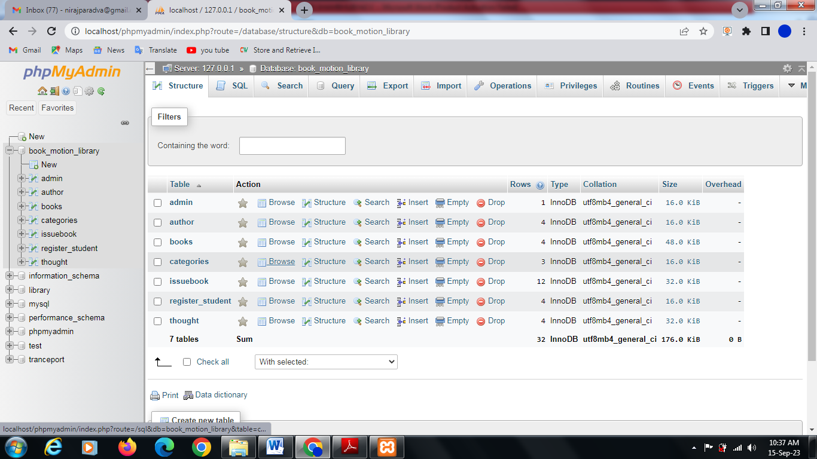

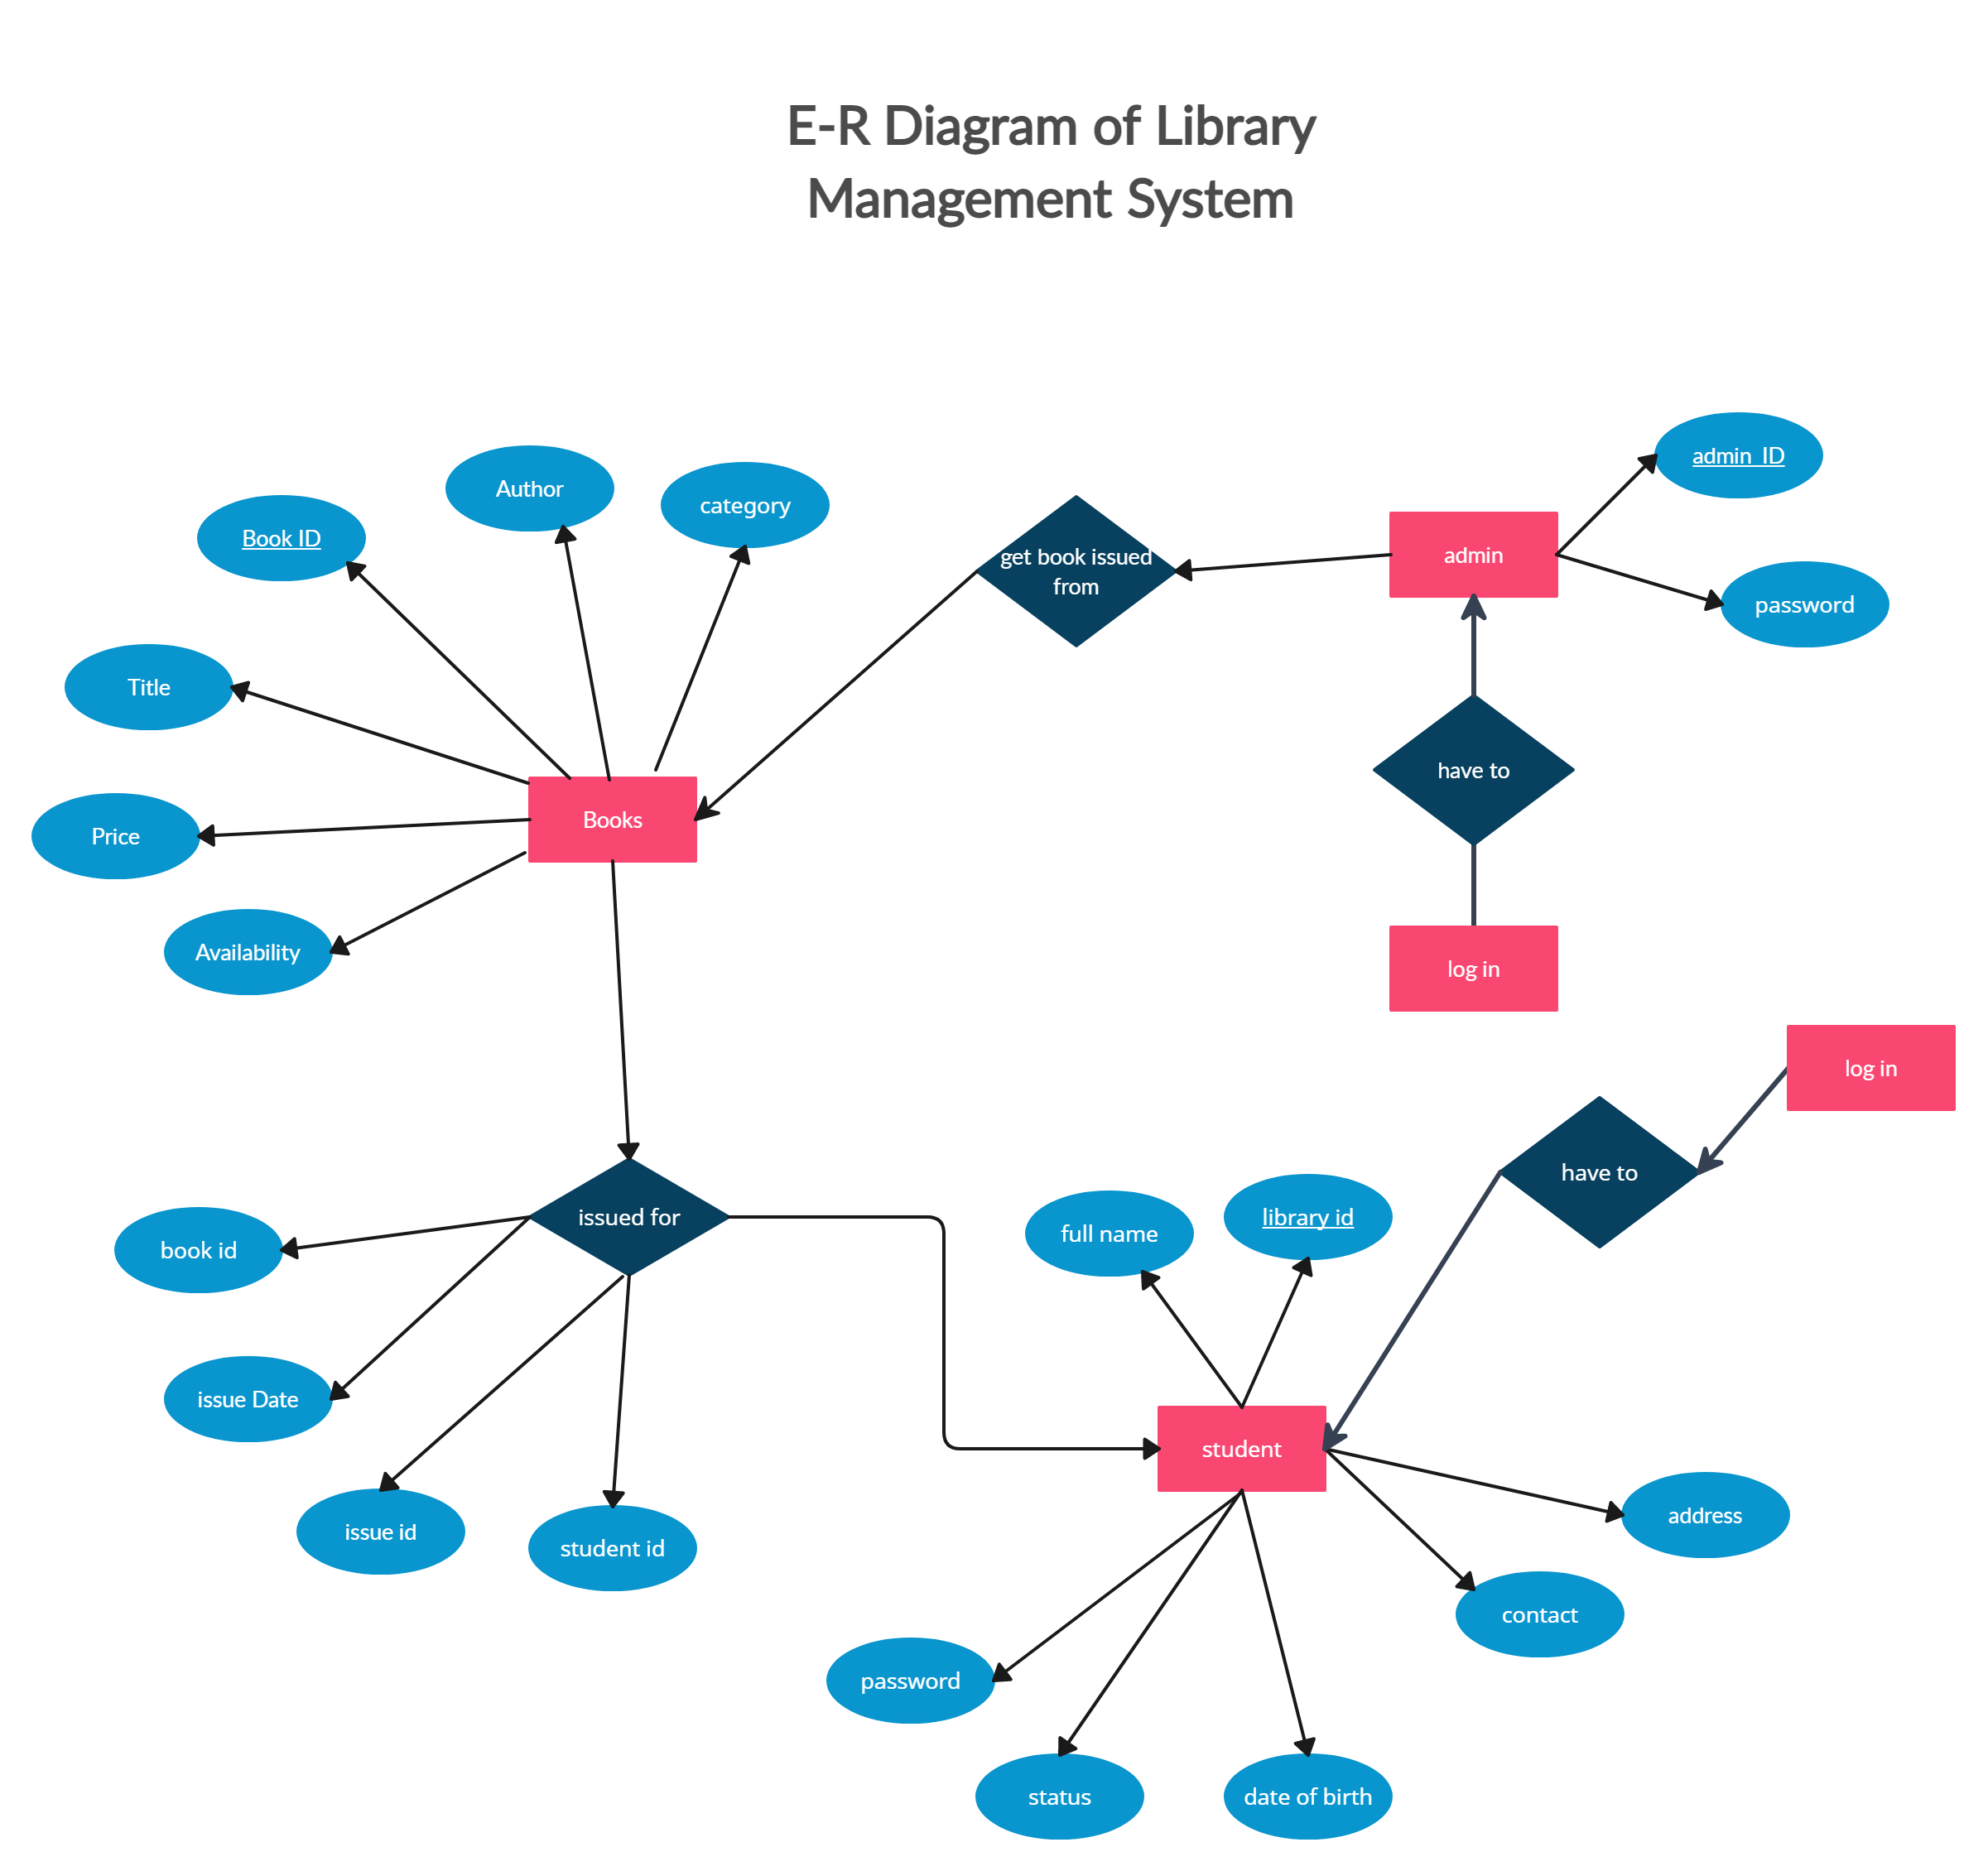

The library database consists of 7 tables,

* Admin- In this table the admin details is stored. Admin can access all the tables.
* Register Student- All the information of the users are saved.
* Books- All the information of the books are saved.
* Author- All the information of the authors are stored.
* Category- All the category of books are saved.
* issuebook- Information’s of all issued book to the users are saved.
* Thought – all the thought who publish and write by student

## data flow diagram

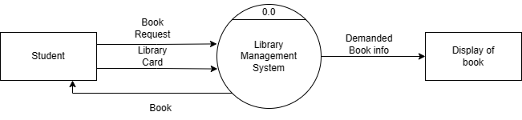

DFD LEVEL-0

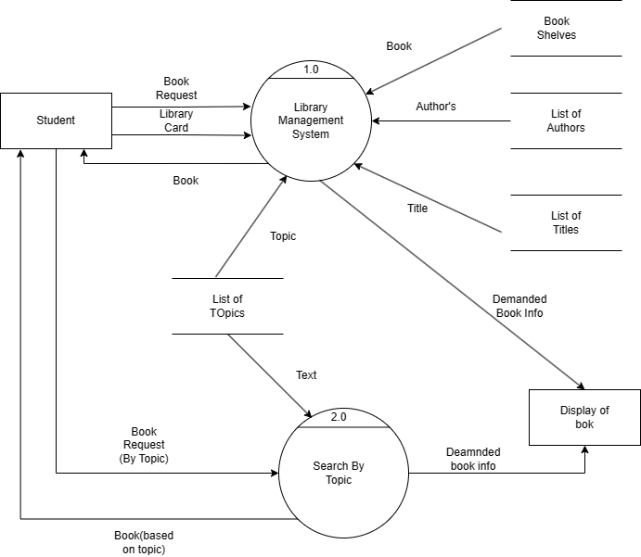

DFD LEVEL-1

## Flow chart

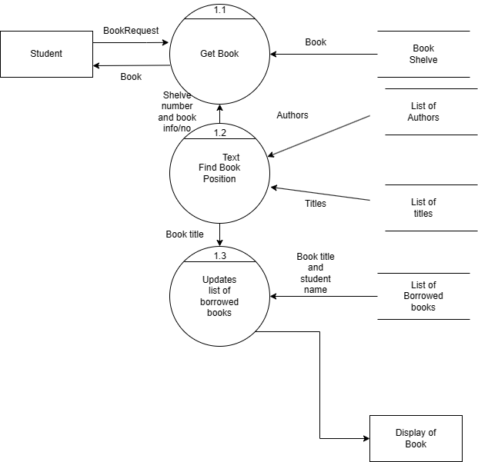

Level 2

# Screen short of site

## home page

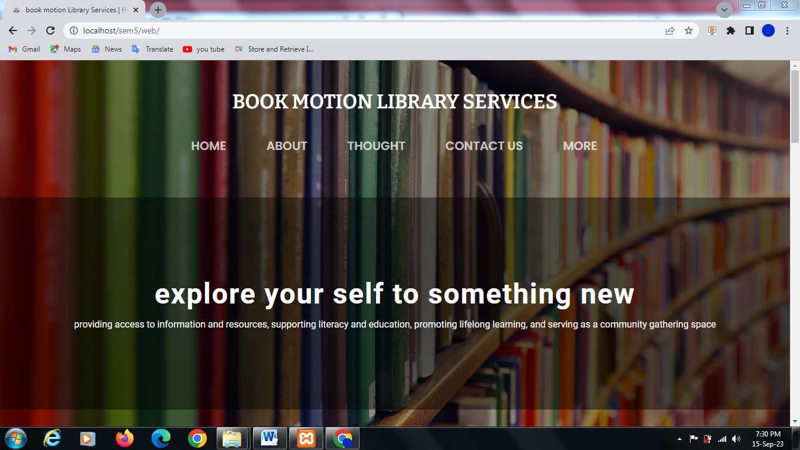

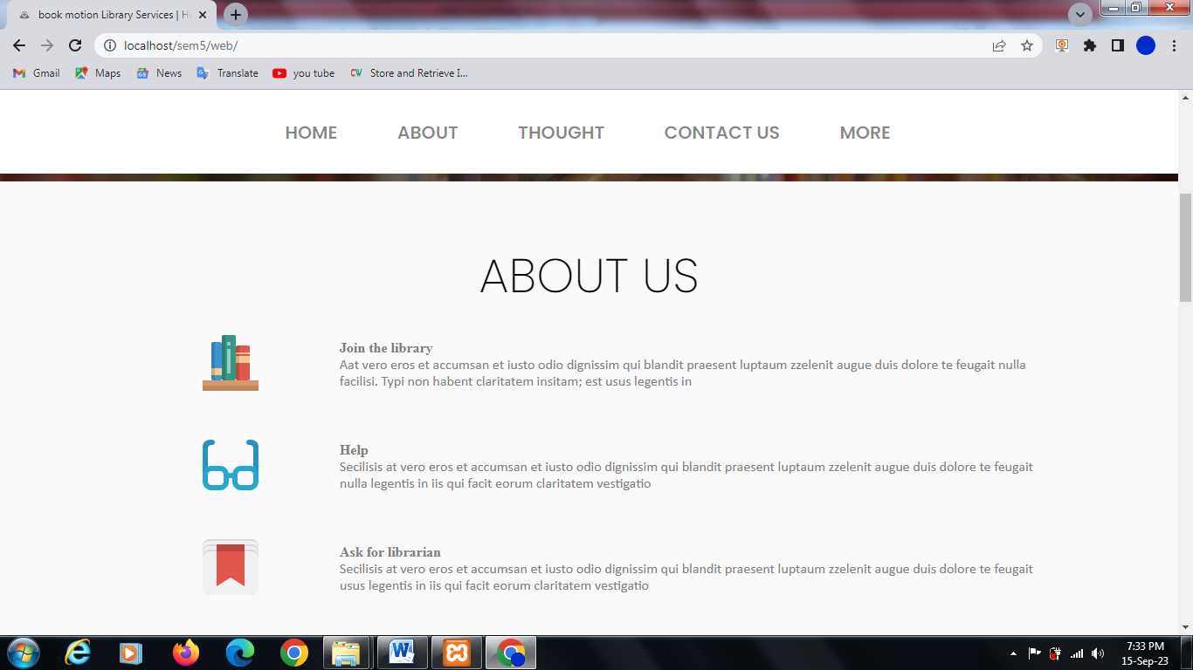

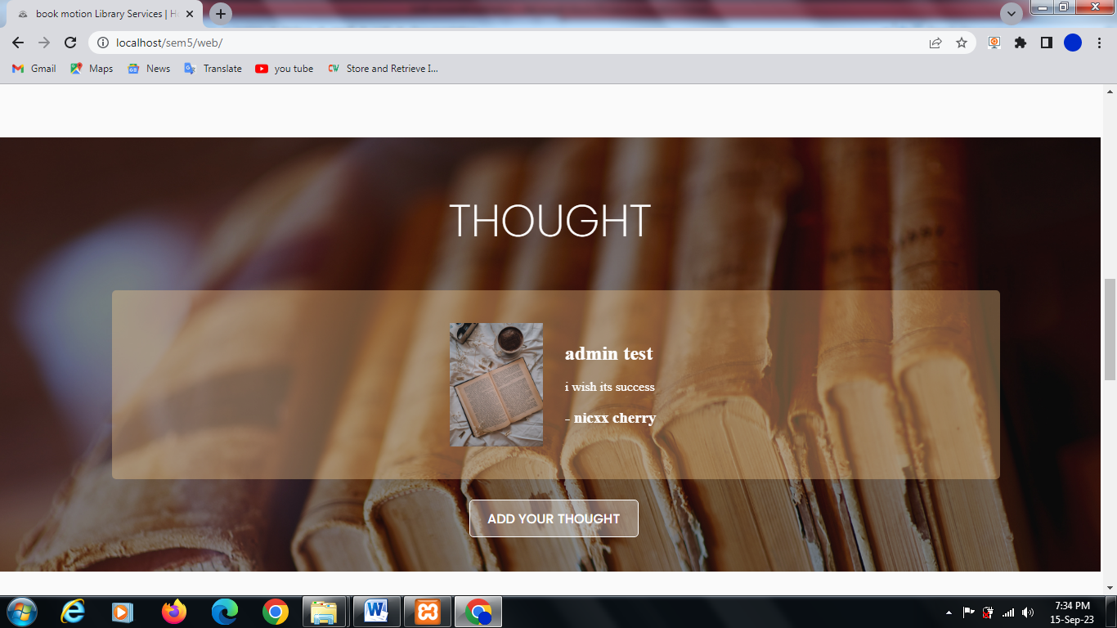

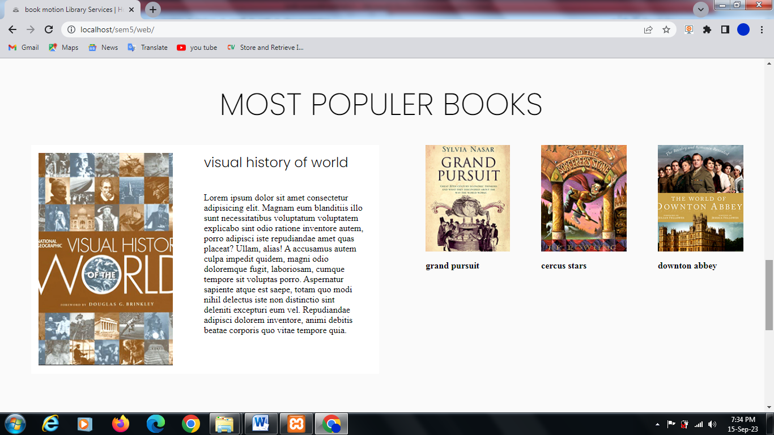

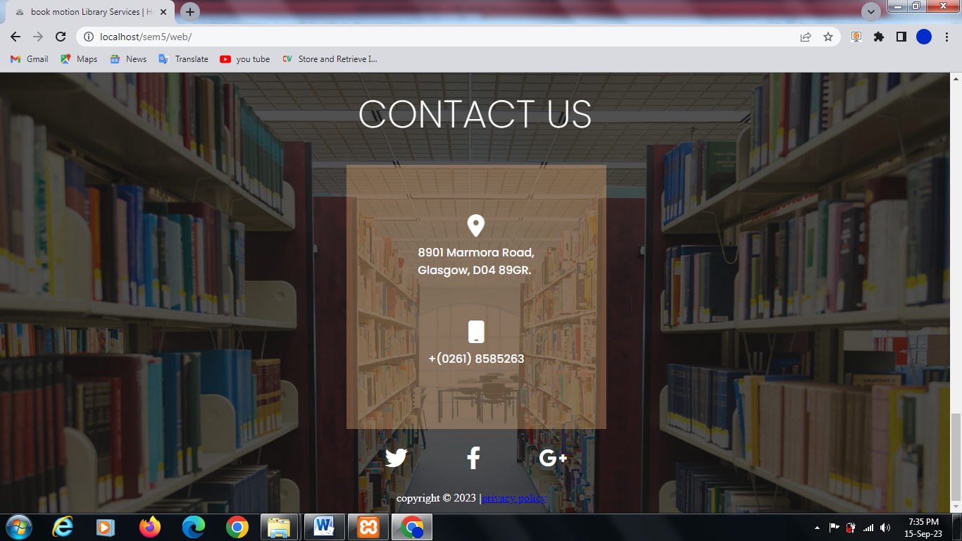

## Register and login forms (admin, student)

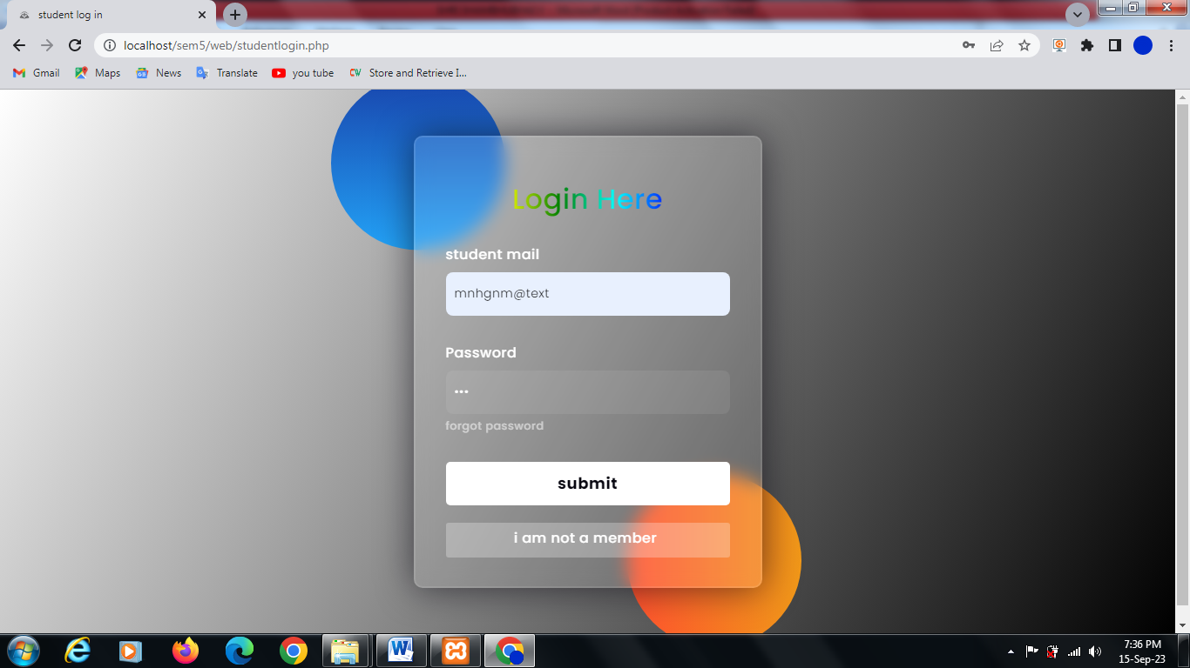

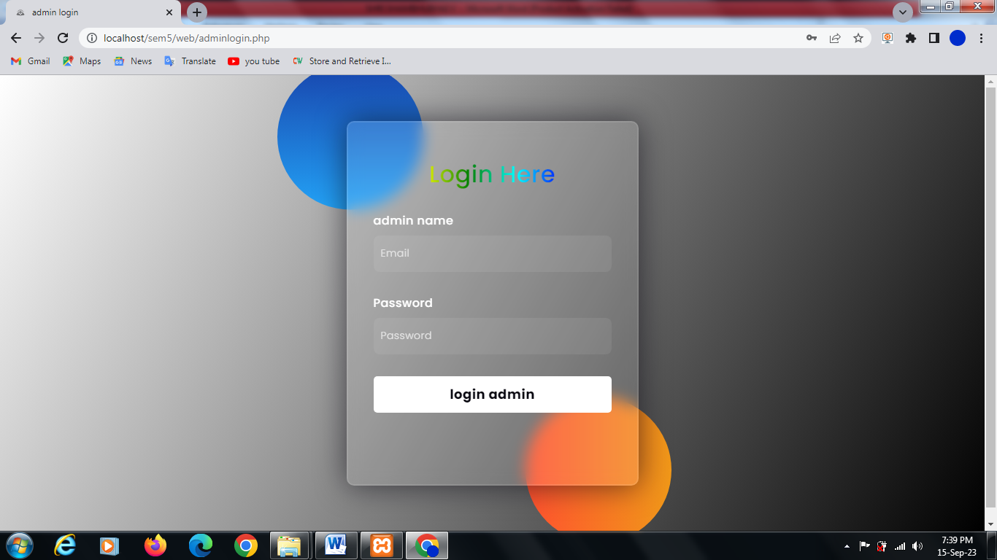

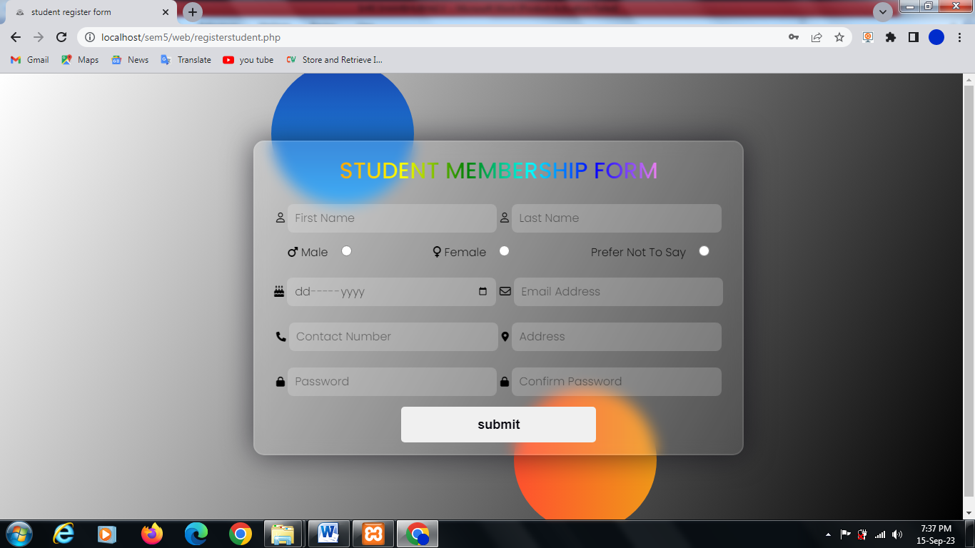

## student dashboard

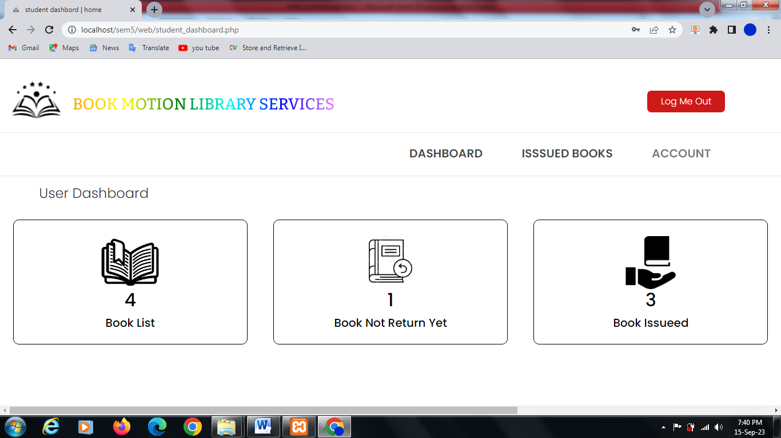

* book list

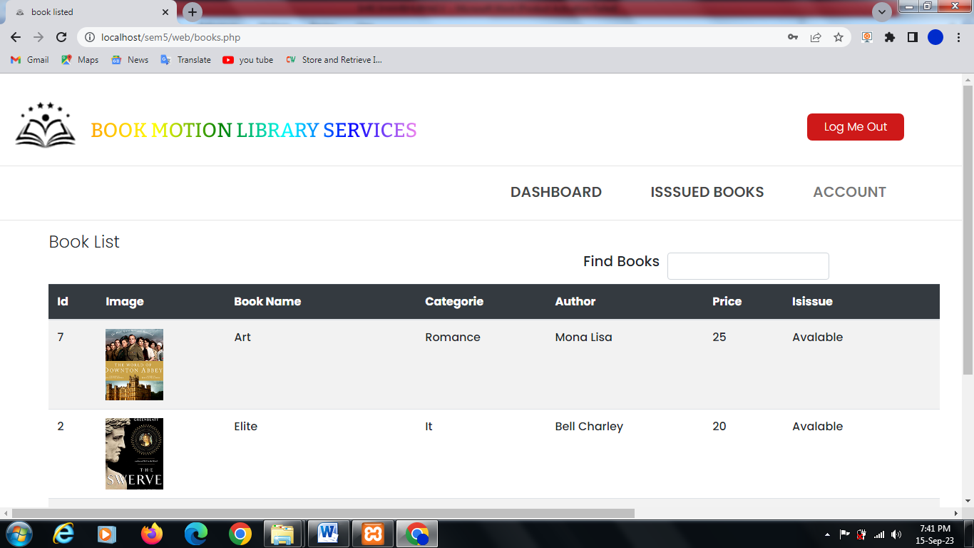

* live search books

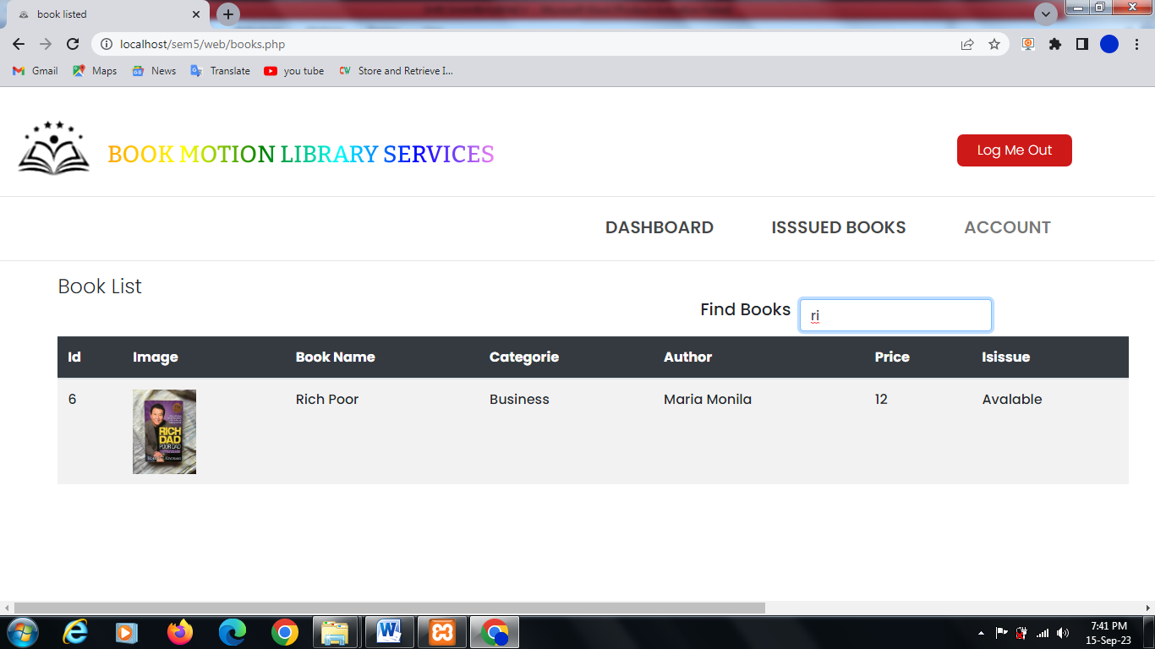

* student book return status

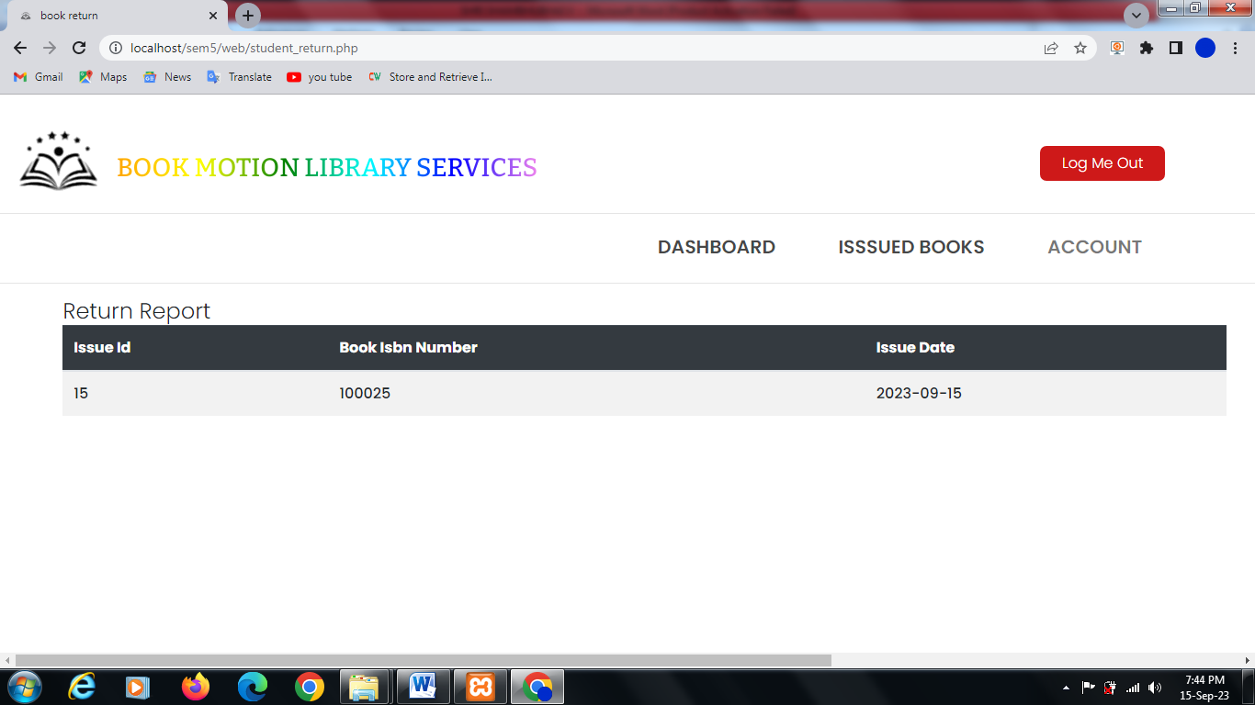

* student profile & update

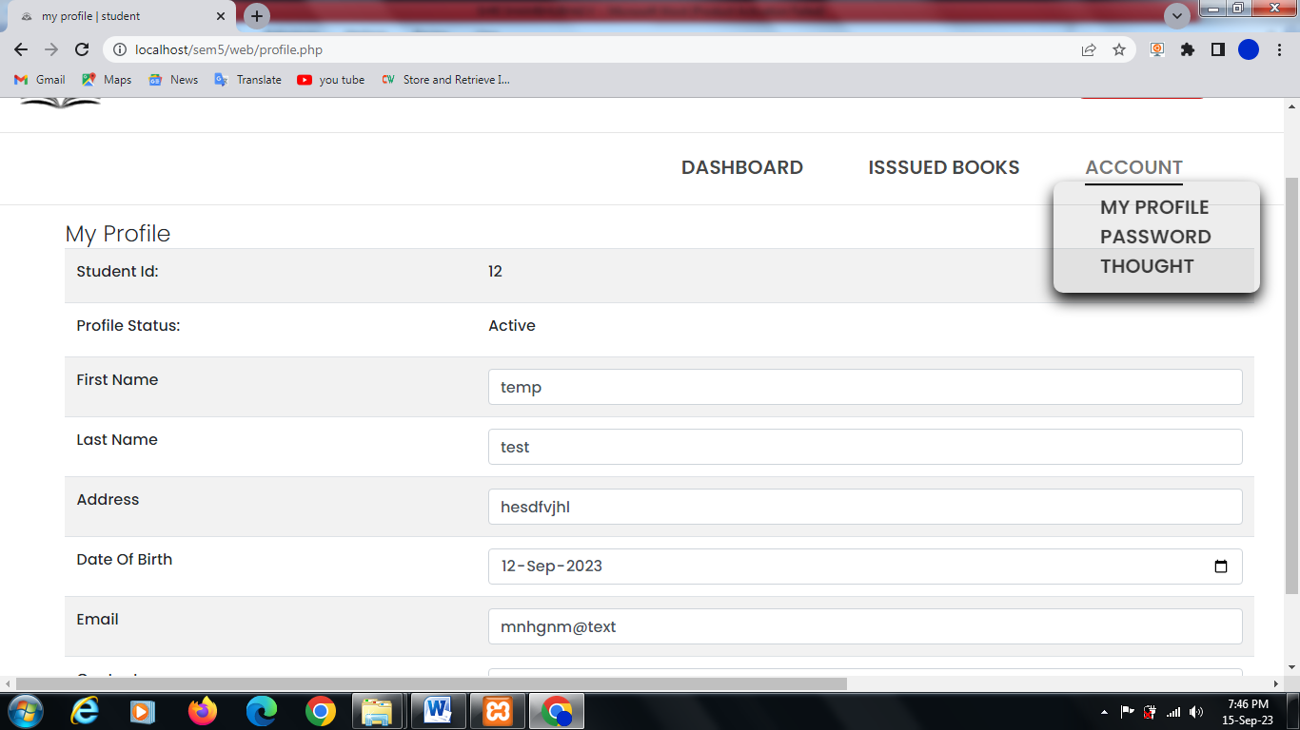

* change password

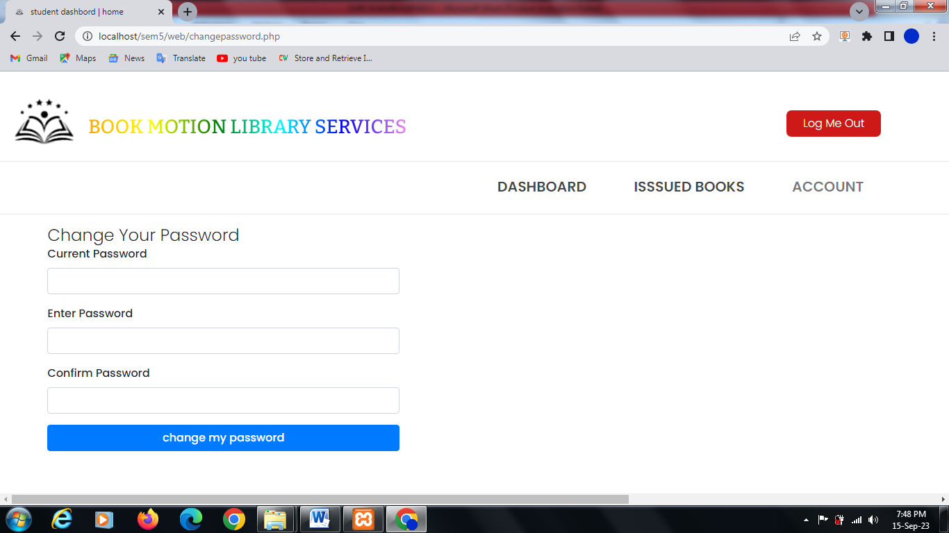

* Add thought by student

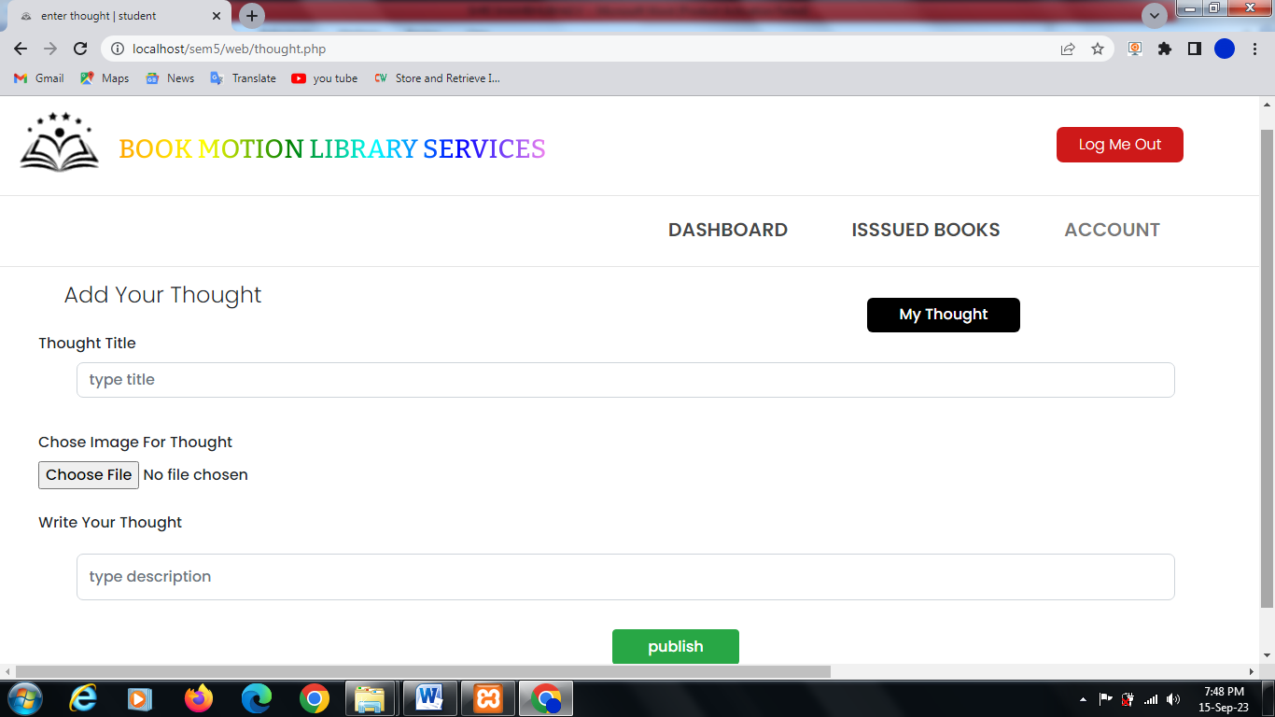

* Show and manage thought

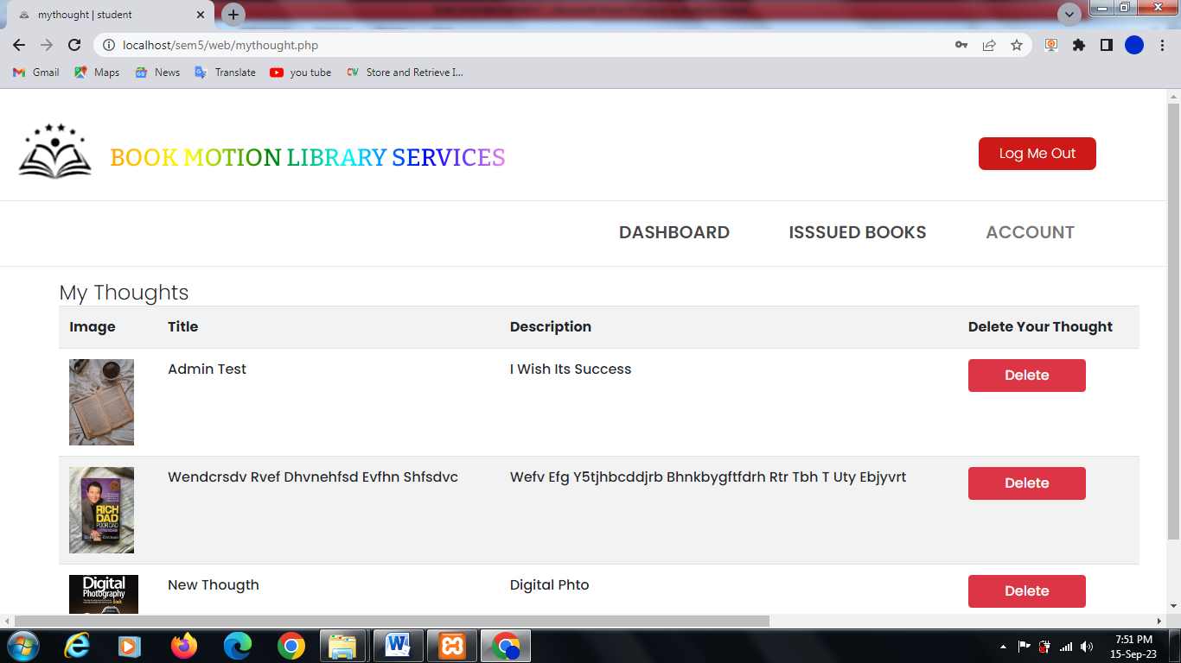

## Admin dashboard

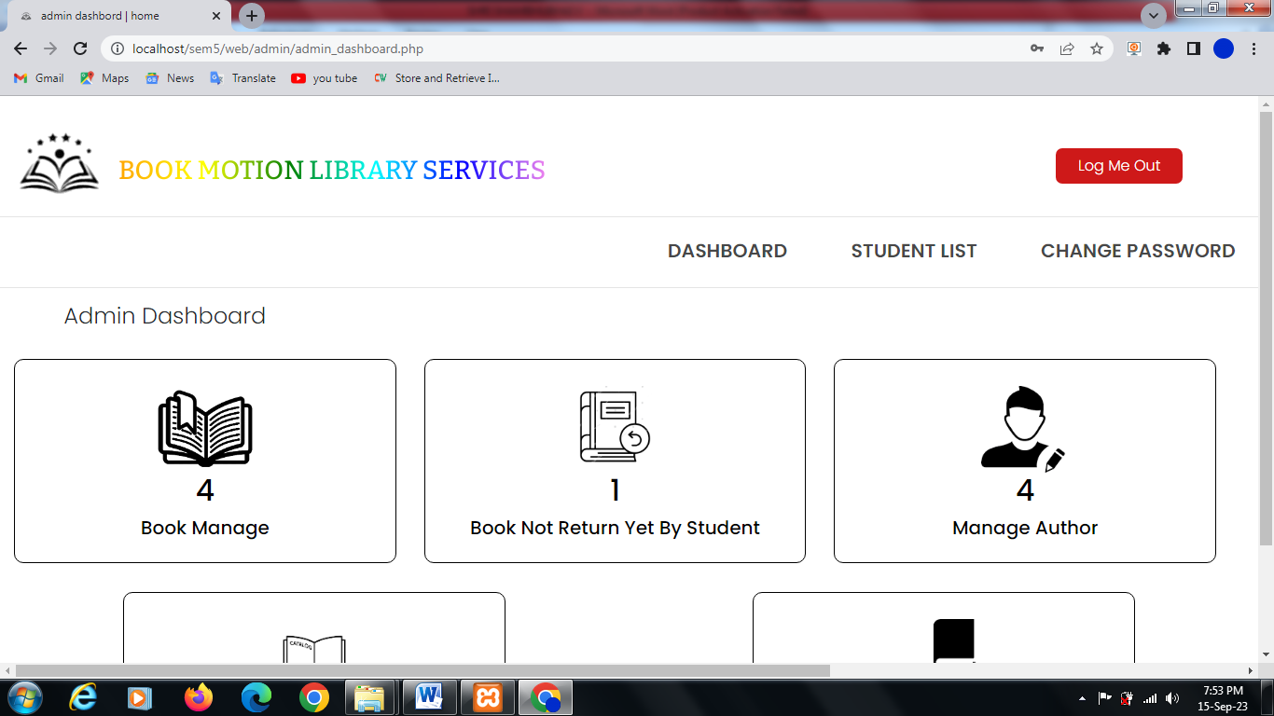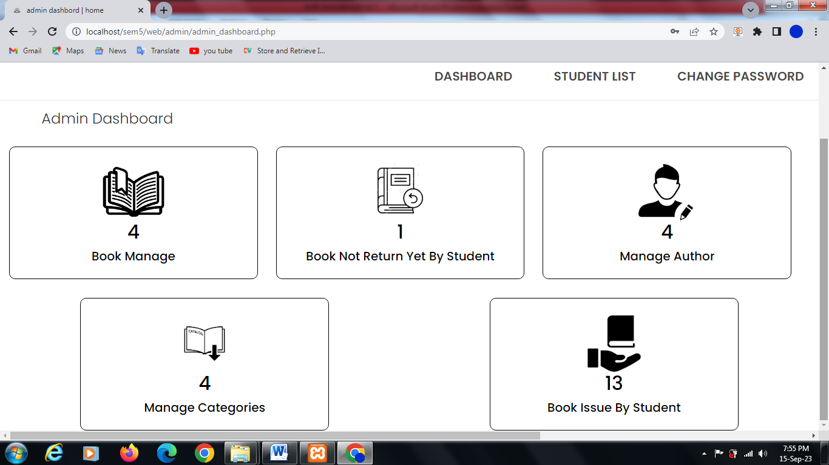

* Book list and maintain

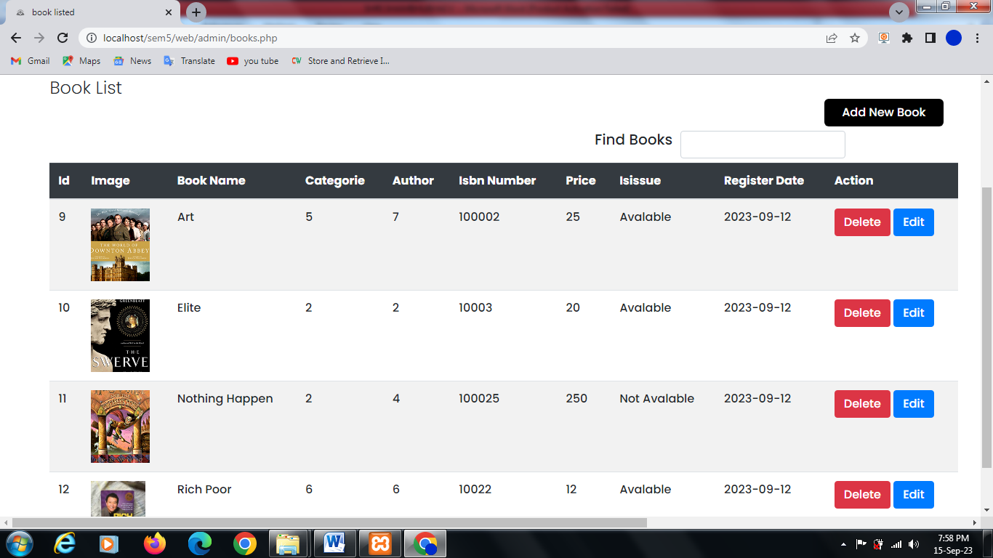

* Book edit by admin

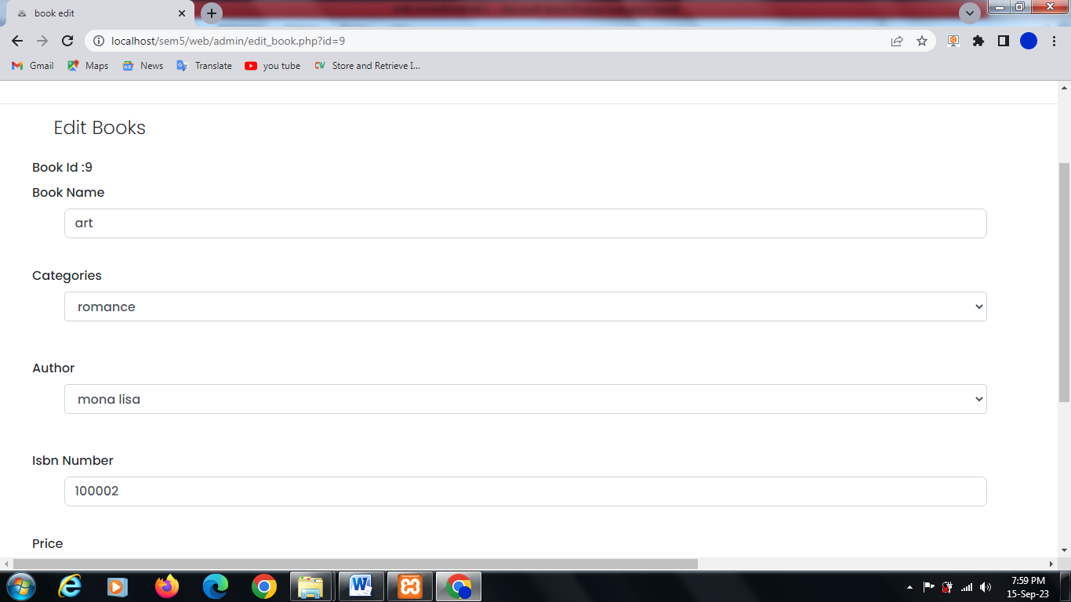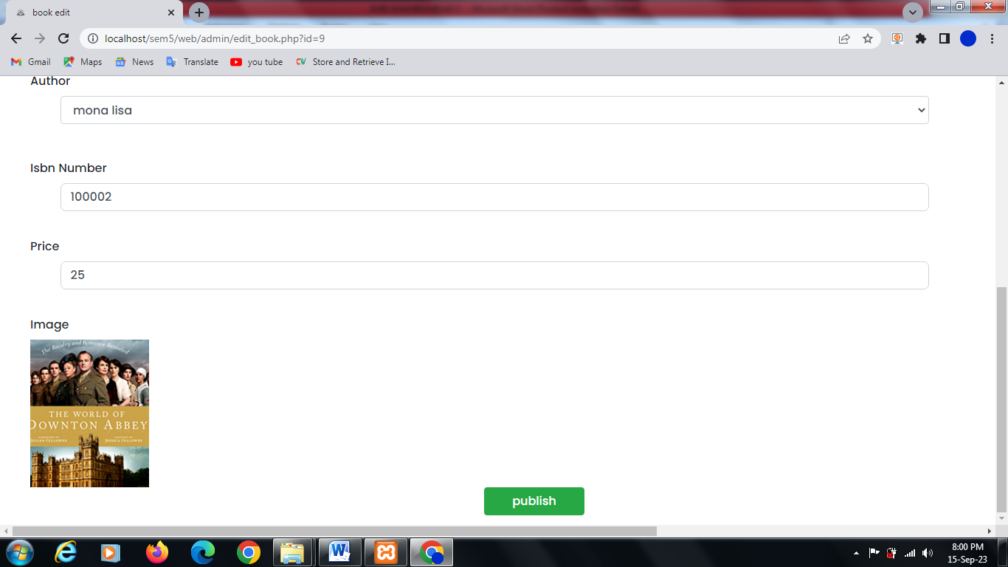

* **Book live search and status**

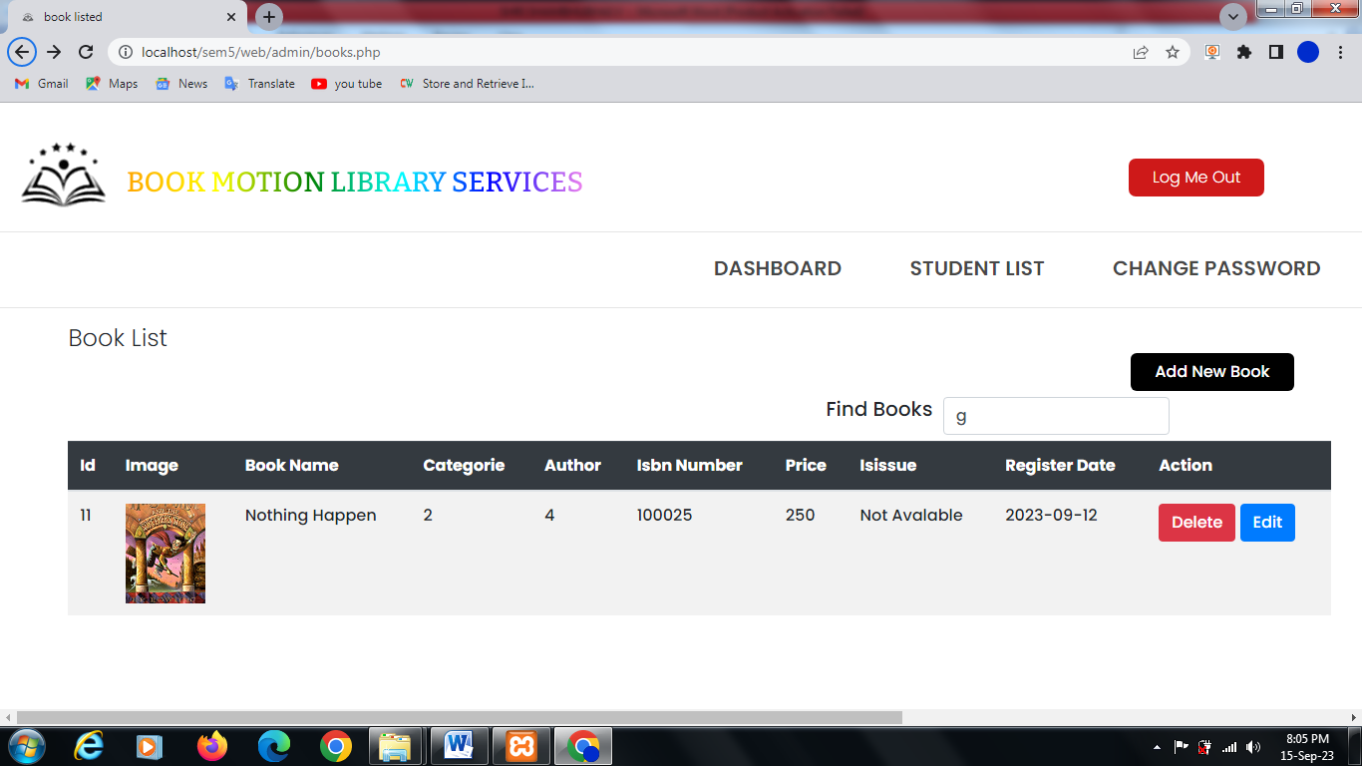

* **New book add**

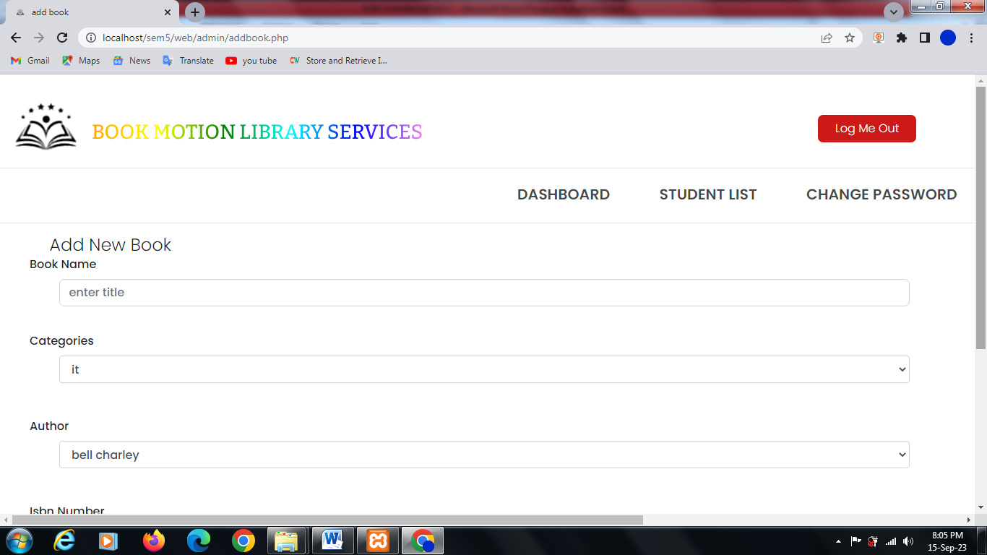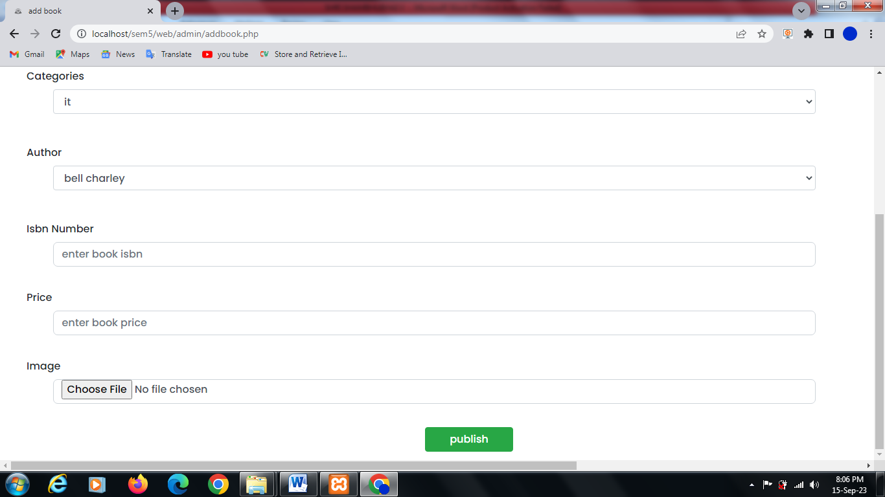

* **info of book which not return and manage**

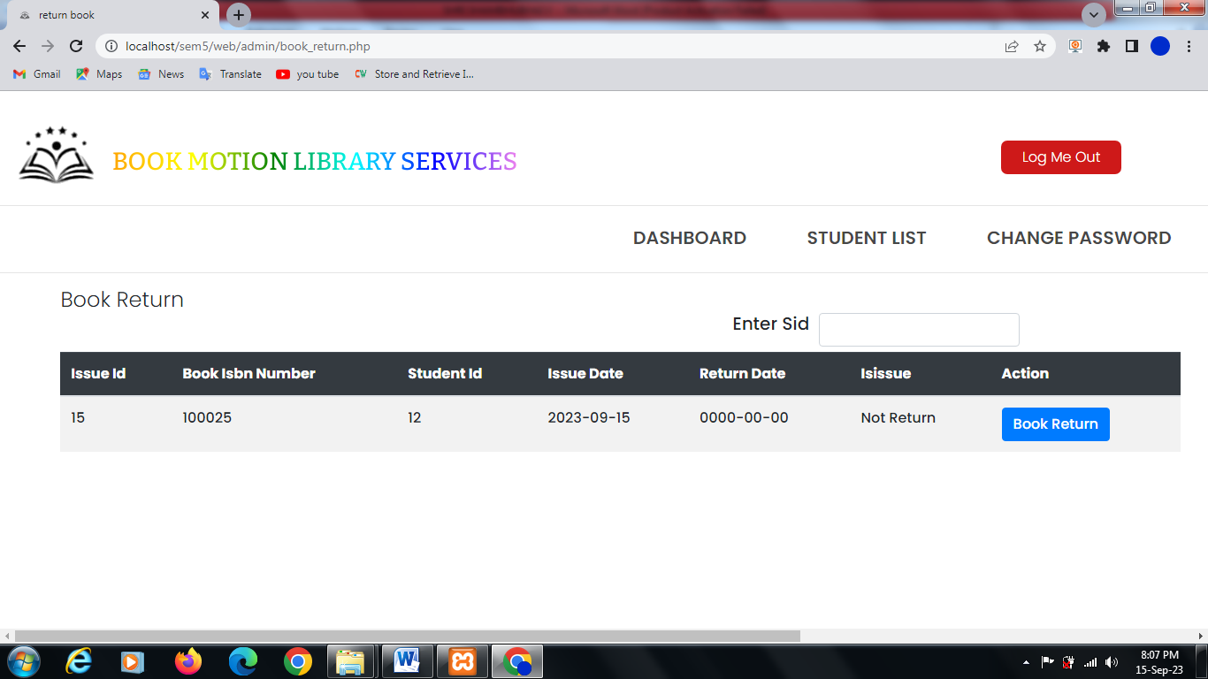

* **register student list, search & manage status**

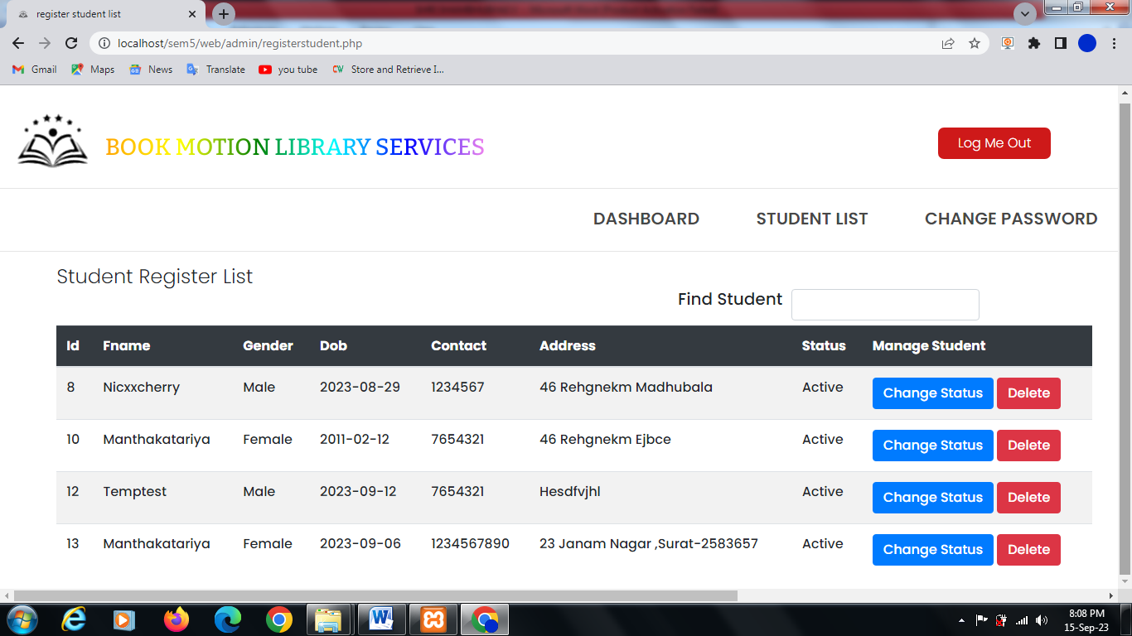

* **admin password**

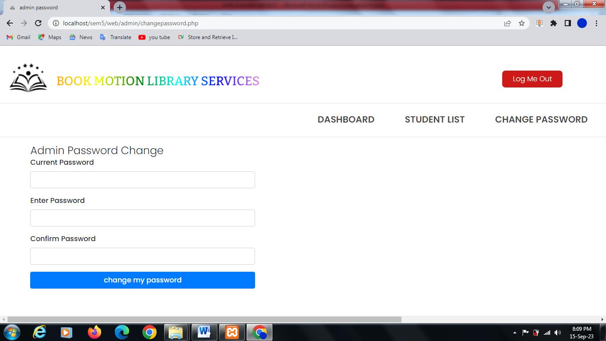

* **manage author**

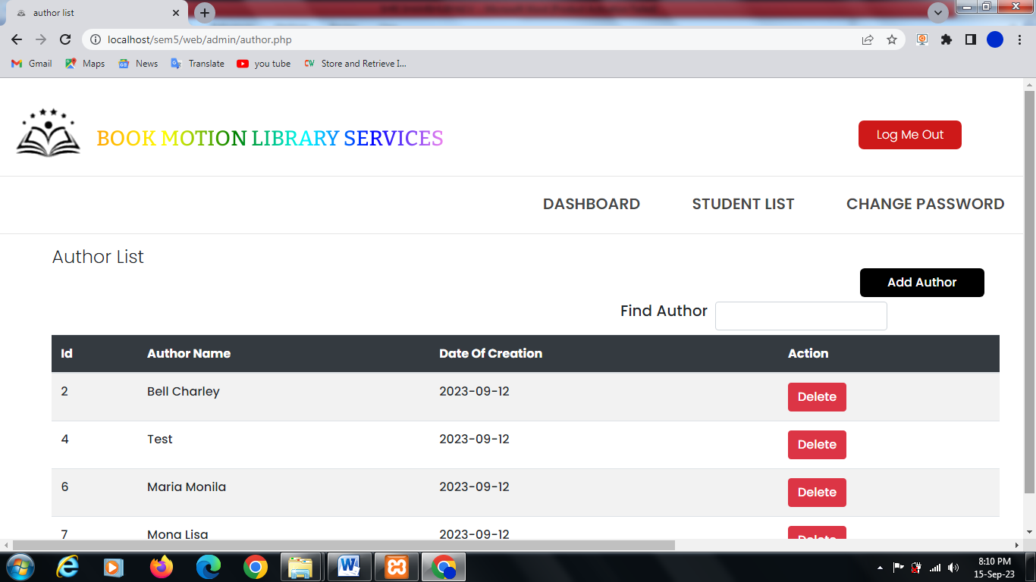

* **add author**

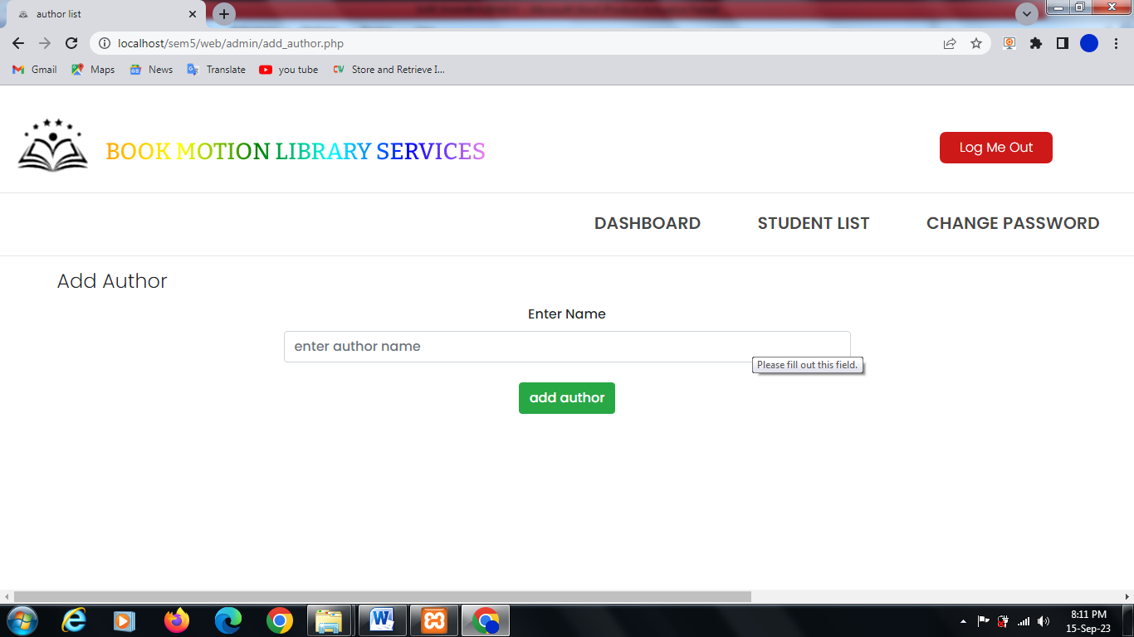

* **manage categories**

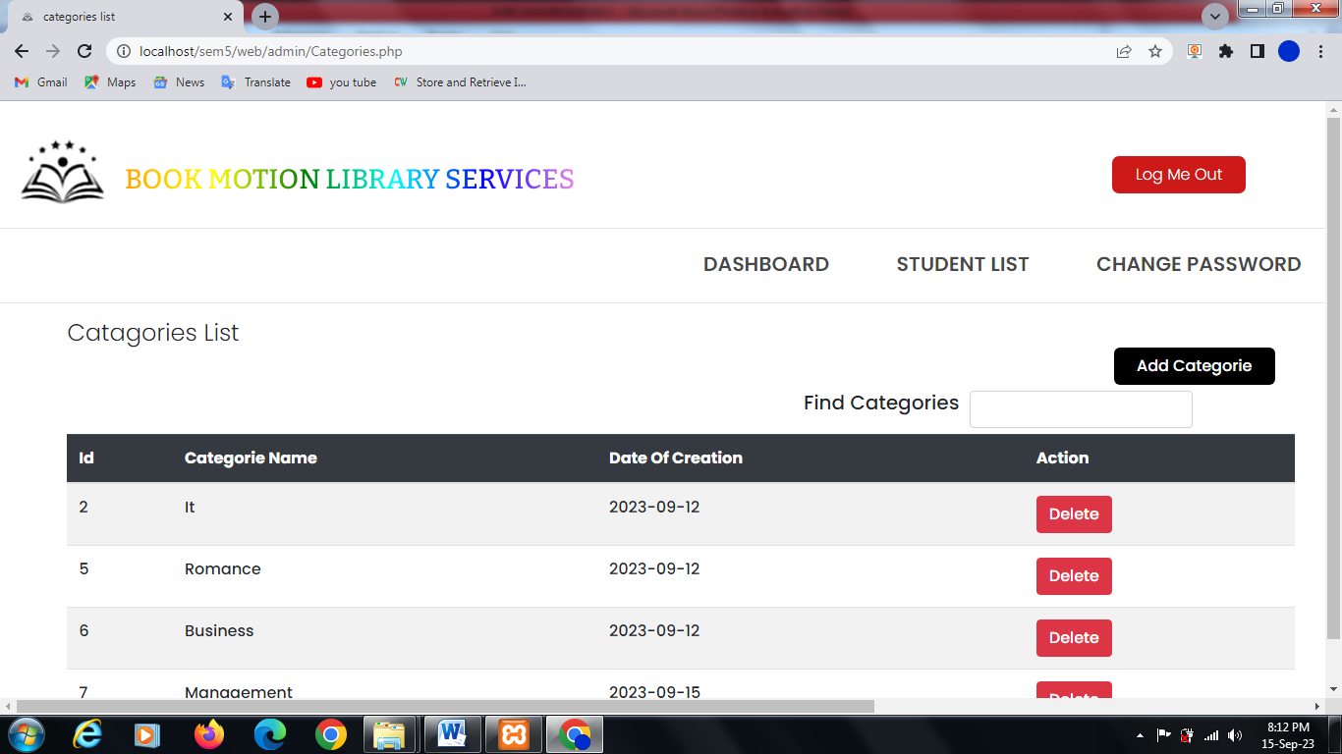

* **add categories**

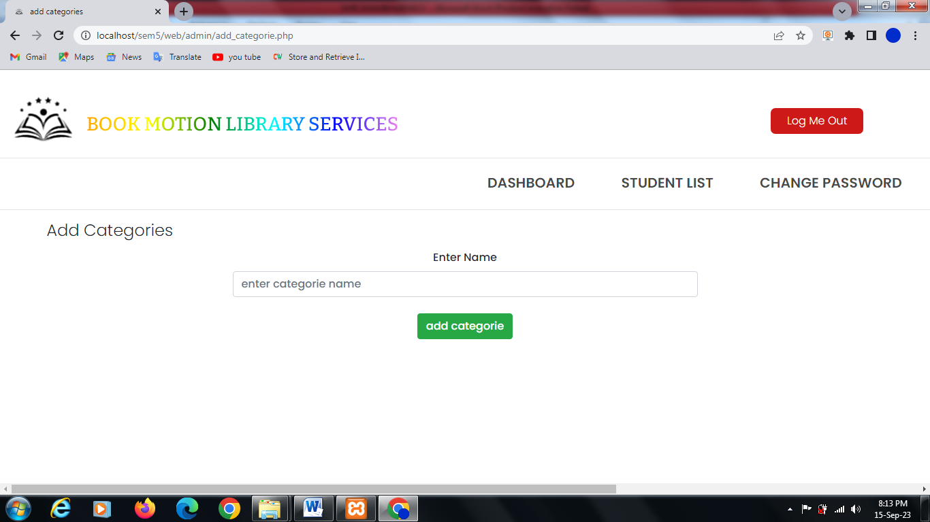

* **book issue for student**

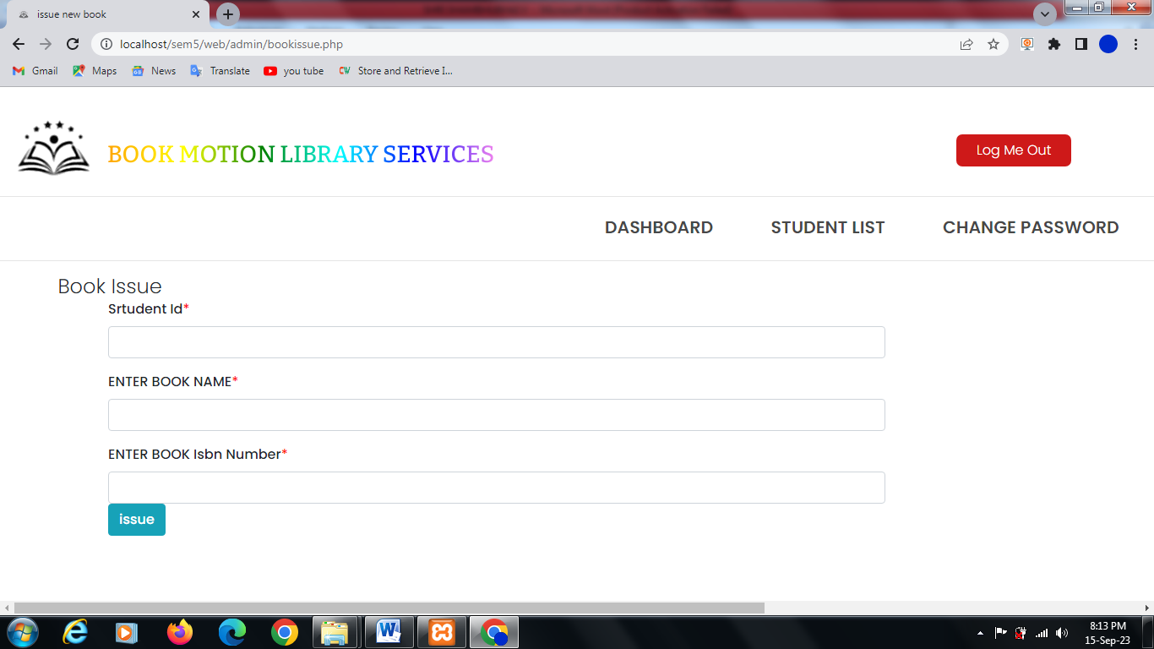

# Conclusion

This project is focused on the development of a system that is both efficient and user friendly when it comes to providing library management service to the users. For achieving the goal, I used PHP, MySQL and JavaScript bootstrap and so on. The challenging part of the project is to design and implement of the database. After overcoming the challenges, I successfully implemented the project and tested it necessary functionalities. All the basic functionality testing is successful which the I planned to do in the LMS. The project is in beginning stage and it’s not fully ready to actual use, as there is need to add more functionality to ensure good user experience. As example currently the user can’t borrow a book directly by themselves. They need to put a request to the admin and the admin can only issue a book to the user. Despite its flaws, the LMS can perform the essential functions required by a library management system.

**References**

**1. design idea**

[**https://demo.templatemonster.com/demo/53902.html?off=consource**](https://demo.templatemonster.com/demo/53902.html?off=consource) **for attractive design.**

**2. uml reference**

[**https://www.scaler.com/topics/er-diagram-for-library-management-system/**](https://www.scaler.com/topics/er-diagram-for-library-management-system/) **for uml designs**

**3. uml designing**

[**https://app.creately.com/**](https://app.creately.com/) **for designing my uml in simple and batter way**

**4.logic reference**

[**https://www.youtube.com/**](https://www.youtube.com/)

1. **Code with harry**
2. **Cyber warier**
3. **Phpgurukul**